Ketch W.E.Gladstone
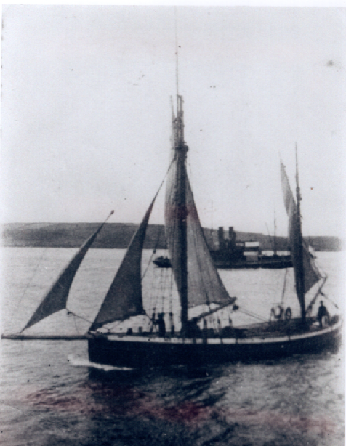
Vessel Name | Official Number |  | Signal letters | Rig /Type | Where built |  | Builder |  | Year built |  |  | Year end |  | reg tons
W E GLADSTONE | 131985 |  |  | Ketch |  | St.Ives |  |  |  | 1885 |  |  | 1931 |  | 23
OWNERS/ MANAGERS/REGISTRATION DETAILS |  | Notes |  |  |  |  |  |  |  |  | MASTERS
Registered Fowey 17th February 1914.1915 Josiah Hunkin, Polruan (MO) |  | 1st on register in 1915 before that in St.Ives as SS30 owners D HOLLOW & G LANDERS. She was not registered in 1931.Laid up in Pont. |  |  |  |  |  |  |  |  | Josiah Hunkin
