Schooner Waterlily
Vessel Name | Official Number |  | Signal letters | Rig /Type | Where built |  | Builder |  | Year built |  |  | Year end |  | reg tons
WATERLILY | 53165 |  | HLGK | 3 masted schooner / Brigantine |  | Newburgh, Fife |  | James Scrimgeour, |  | 1866 |  |  | 1890 |  | 169
OWNERS/ MANAGERS/REGISTRATION DETAILS |  | Notes |  |  |  |  |  |  |  |  | MASTERS
registered in Fowey 7th June 1866. 1870 Henry Lamb, Fowey, 1890 Hoskin ,Polruan (mo) |  | LOA 95.5 x 22.1 x 11.9ft In December 1890 Whilst sheltering near the Lizard she was run down by a French Barque and sank. The crew were saved by the French vessel and landed in France. |  |  |  |  |  |  |  |  | W.Hocken 1867-1874 Davies 1877-79 Albert Slade 1880-1881 Pollard 1880-83 Scantlebury 1883 Phillips 1883 Candy 1887 Climo 1886-90 Burnett 1890
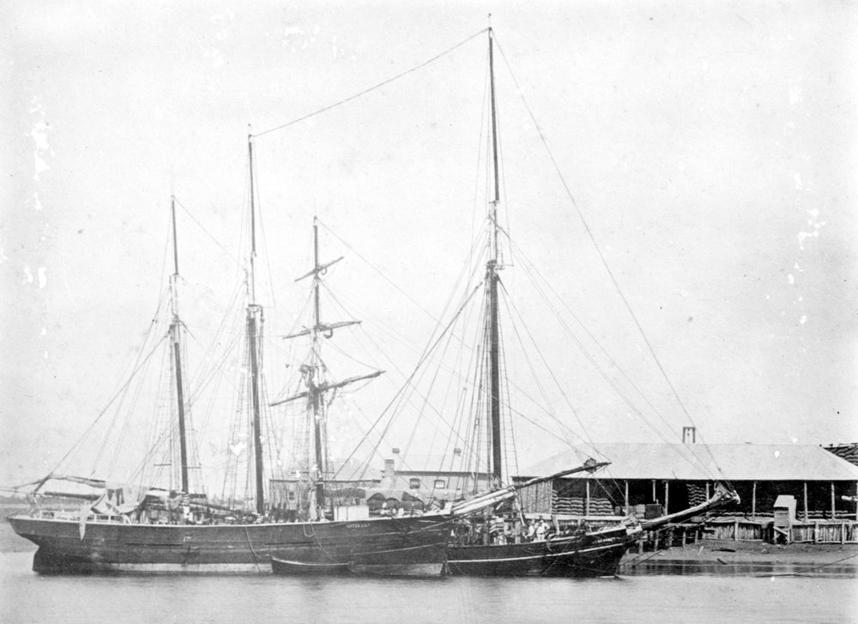
Waterlily waiting to load

Name | Official number | Flag | IMO
WATER LILY | 53165 | GBR
Year built | Date launched | Date completed
1866
Vessel type | Vessel description
Cargo General | Wood Sailing Vessel Schooner
Builder |  | Yard | Yard no
James Scrimgeour, Newburgh, Fife

Tonnage | Length | Breadth | Depth | Draft
169 grt / 158 nrt / | 95.5 ft | 22.1 ft | 11.9 ft
Engine builder | ,
Engine detail

First owner | First port of register | Registration date
 | Fowey | 07/06/1866
Other names
WATERLILY
Subsequent owner and registration history
By 1870 Henry Lamb & Co., Fowey.
By 1890 John E. Hocken, Polruan, Cornwall.
Vessel history
By 1880 Brigantine.

