Schooner Waterwitch
Vessel Name | Official Number |  | Signal letters | Rig /Type | Where built |  | Builder |  | Year built |  |  | Year end |  | reg tons
WATER WITCH | 62194 |  | SJVH | Brigantine Barkantine |  | Poole rebuilt Par |  | Thomas Meadus |  | 1872 1918 |  |  | 1944 |  | 167
OWNERS/ MANAGERS/REGISTRATION DETAILS |  | Notes |  |  |  |  |  |  |  |  | MASTERS
1872 Henry and James Ash, Portsmouth .1910 J.D.Mutton but reg in Portsmouth. 1919 Edward Stephens, Par (MO) 1937 Miss Annie Stephens,Treglines, Par /Thomas J. Stephens, 3 Elm Park,Par. |  | registered in Portsmouth 24th May 1872. LOA 112 ft x 25.8ft x 12.8 ft 22nd April 1875 was in collision with another \brigantine Wilsons of Colchester. she sustained damage and put into Hartlepool for repairs. 1916 bought by Edward Stephens damaged in Newlyn Towed to Par in May 1918. Rebuilt by Tregaskis started life as a Brigantine converted to a barque in 1920 in Par. Previously registered in Portsmouth. sold to Finland in 1939 for £325. owners J.Riis and others registered in Tallin, Estonia. originally used on fruit trade and stockfish. Often crewed by Trinty house pilot apprentices gaining sea time for their certificates. |  |  |  |  |  |  |  |  | T.Meades 1872-83 Thomas 1881 Madgwick 1884 -85 Thomas 1881 H.H.Gardener to 1900 J.Smith Pennicott Thomas Mutton 1910 to 1916 Bate 1916-18 Charles Henry Deacon 1918-1935 B.R.Carrivick 1935-1936

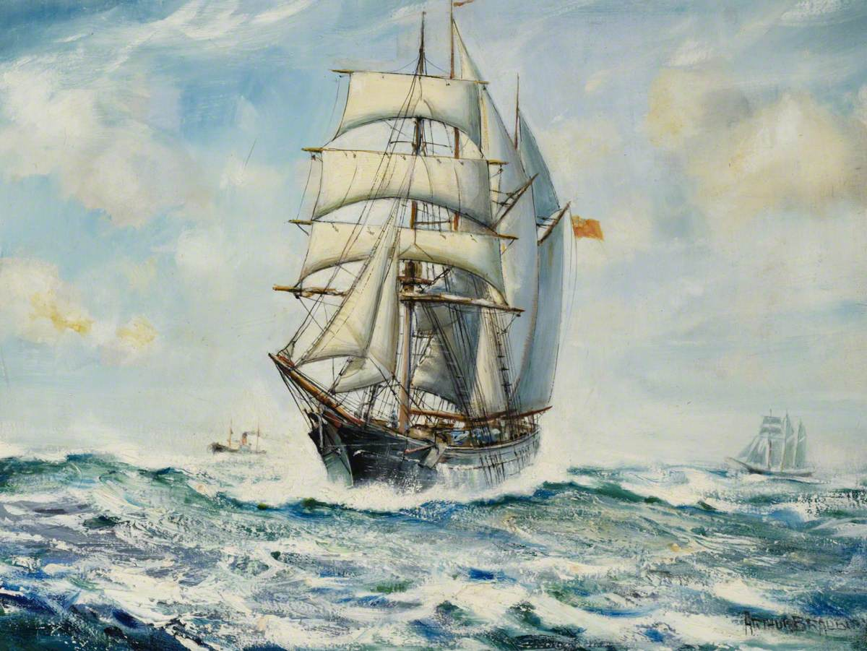
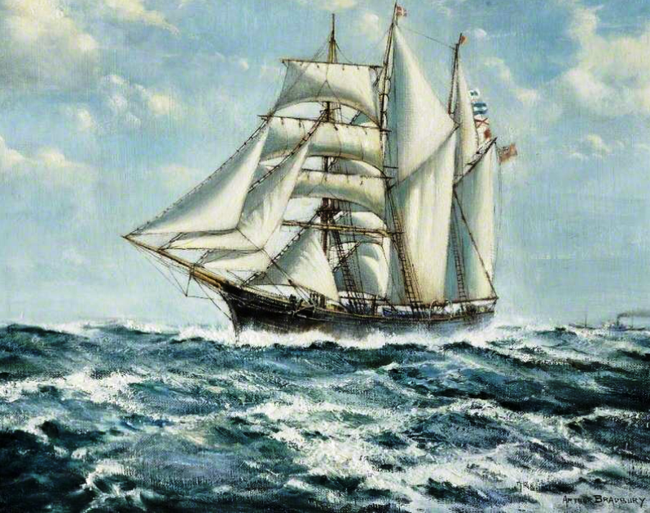

The Fowey Barquentine 'Waterwitch' off Dover
Arthur Royce Bradbury (1892–1977)
Russell-Cotes Art Gallery & Museum
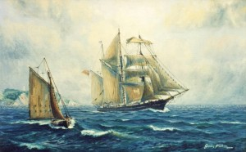

off Gribbin Head painting by Gordon Frickers
Measuring 112 feet in length by 25 feet in the beam and a tonnage of 206 gross,

Below an article largely based on one by Gordon Frickers from his research on the Waterwitch
The name most associated with Par harbour, Tregaskes appeared in the 1860’s, when a Saint Austell merchant, Samuel Moss launched the schooner, “Lizzie Trenberth”, built by chief shipwright Richard Tregaskes.
It was his son, who was apprenticed to the yard and served at sea and work a while in America Benjamin Moss Tregaskes who repaired the Stephens Fleet including Waterwitch and Jane Banks.
The barquentine “Waterwitch” was built at Poole, Dorset as an ocean-going brig and operated as such, a deep water trading vessel with 2 masts both square rigged. In 1872 Thomas Meadus completed 2 years building, when his new 206.26 registered ton brig “Waterwitch” put to sea. She was 112′ stem to aft head posts, beam 25.8′, very solidly & soundly built, and apparently framed of surplus oak purchased from Portsmouth Naval Dockyard. Her keel was American & English elm, the rest of English oak with 3½” (minimum) pitch pine for planking & English Elm below the waterline fastened with tree nails & yellow bolts, reinforced with iron Knees and she was salted throughout. She did not have a figure head. “Waterwitch” was originally rigged with double topsails, single top gallants and royals on both fore & main masts. Second ship of the year 1872 registered at Portsmouth, she was owned by Henry & James Ash, coal & potato merchants.
She could set studding sails & was crewed by a master, Captain William Meades, certificated, aged 32 of Southsea, plus mate, cook, two able & three ordinary seamen.
This was increased to 10 in winters.
She traded coastal in particular to Hull, Newcastle, London, Liverpool, Swansea and too much of Europe including the Spanish Islands for fresh fruit, even to North America. In her later years she experienced many aspects of the home trade eventually owned at and operating from Fowey, Cornwall as part of the John Stephens fleet.
Of her early voyages, we know she started in ballast from Poole for Swansea where she loaded coal for Dieppe. In those days the British still favoured brigs over schooners. She worked in the fruit trade where she was considered fast. She then made 9 round trips to Sunderland for coal to Seaham harbour, Portsmouth, or Cowes before making her first transatlantic voyage in ballast to Montreal for wheat which was discharged at Galway.
Most of her voyages were in the home trade, frequently to France.
She was destined to become the last square-rigged engineless ship registered at a British port regularly carrying cargo.
The whole crew of ten ate at the master’s table. The master’ pay was £8:10s per voyage made very profitable if he did a good job of the ship’s office work. Crew sailed for a 30 day month at £5:10s for a mate & £3:10s for an able seaman. She had good (for the times) accommodation for her master, not unusual for vessels of her type. His paneled cabin set in the aft triangle of the ship was entered down a companionway that made a 90 degree turn in about 9 feet of fall. Cramped but comfortable, the 2 cabin sides were fitted with narrow hard upholstered seats, backed by panels rising 3 feet, above which were shelves with “stanchion” style fiddle rails, covered with “sea junk”. Above the shelf were paneled lockers to the deck head. Aft, a square mirror was let into the paneling. Built into the bulkhead, portside for’ard was originally a cast iron stove, later a cast iron fireplace; starboard side was a door leading to the companionway & the mate’s cabin. Between the seats on a single stem, a triangular folding table. The hollow structure of a skylight occupied part of the deck head, below it swung a large oil lamp & a telltale compass was fixed at the aft end of the skylight.
The master would be able to hear the helmsman above & the creak of the steering gear aft.
She seems to have been a happy ship, throughout her life it was difficult to get a berth on her.
She was not a particularly fast ship, but a powerful one. Well handled, she sometimes made 2 trips when most other ships made one. She soon built a reputation for speed which stayed with her for her life.
She was badly damaged in foul weather in 1877 so had to undergo extensive repairs.
Her first change in appearance came after a collision in the Solent with a steamer that cost her bows, bowsprit & jib boom. Taken into Portsmouth by a naval tug, she reemerged with a straight stem & standing bowsprit, still no figurehead.
Her next commander, Captain Madgewick had her altered in 1884 at Seaham, during a series of visits. As an economy measure, she was altered to the handier Barquentine rig.
Her masts were moved & altered & a mizzen added. Her foremast was re-stepped, the main yards moved to the fore & the main scrapped.
She still sported Studding sail booms which she kept until 1916.During the changes she made several voyages & one results was her being listed at Lloyds before her new mizzen was stepped, incorrectly as brigantine.
Captain Madgewick was unlucky enough to fall overboard & drown, on New Year’s Day, 1885.
Captain Harry Gardner took her next & under him she acquired the right to take her turn with fully powered steamers at the Northern loading piers at Hull and Newcastle.
She acquired the nickname of Ash’s Steamer because of her reliable regular passages.
She had a reputation for being a hard case ship, and was also known among the seamen as the “Portsmouth Workhouse“!
For the following 38 years she worked mostly carrying coal from the North to the Camber at Portsmouth. She had too deep a draft to be really suitable for most coastal harbours. However, her modified rig was very successful. During these hard driven years, she was maintained mostly at Littlehampton, Sussex, Harvey’s Yard. Their records show major services in 1896 for much re-planking, 1901 for sheathing & again in 1907.
She stayed with the Ash family until the firm was dissolved in 1905.
She was bought by Lt-Col A.E. Flowers of Portsmouth & continued in the same trade.
In October 1910 at the age of 32 she changed owners again, became a West Country, Cornish ship, purchased by Mr. W.J.D. Mutton of Fowey. She was refitted at Truro. She went to sea under Captain Thomas Mutton, based at Falmouth, trading mostly with China clay to the Mersey & began an even harder career, a new even more active life mostly to South Wales & the Mersey, the next Severn years being particularly adventurous.
Besides the hazards of the sea, she was in and out of France and she had 2 brushes with enemy submarines, the second being a torpedo attack which happily failed before the torpedo reached her.
She continued to often carry China Clay, mostly to the Mersey. In 1916, Captain Mutton retired & was replaced by Captain Bate who sailed “Waterwitch” to France thence to the Mersey where she suffered a collision so severe she was 4 months under repair, a financial disaster. It was the beginning of a hard time for Captain Bate and his crew.
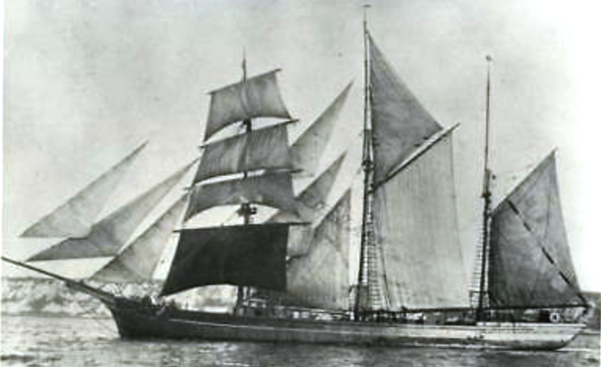
At the first opportunity, repaired, she spread sail for the open sea; she left Liverpool, and the Mersey heavily laden with coal for her home port of Falmouth. Off the Longships rocks (Land’s End), a South – Easterly gale sprang up with a heavy threatening swell. Captain Bate decided to put her hard on the wind for the Lizard peninsular. They did well to clear Land’s End but found with the big seas and strong currents she could not weather the dangerous Lizard so he put her into Mount’s Bay to lie in the relative shelter of the lee of Mullion Roads. Two anchors were laid, soon both cables parted. “Waterwitch” was forced off the shore, her crew had to hurry to set sail & square away before the gale. With the small Port of Newlyn under her lee at the other side of the bay she had little time and little choice but to try for the wave swept entrance. The flood tide was making, there was 12 feet of water in the harbour entrance & “Waterwitch” had nowhere else to go except the beach or the rocks.
Unfortunately, heavily loaded as she was and with that swell, she needed more than the 13′ 9″ she was drawing aft. As “Waterwitch” entered Newlyn Harbour she struck the bottom with such force that 30′ of her keel & her rudder were torn off. She was lucky not to be dismasted.
The rising tide lifted the stricken vessel. Leaking badly, she drifted onto the North pier outside the harbour proper. The Navy intervened, using boats to tow her back to the harbour only to have her hit bottom again in the entrance. This time the shock upset her cabin stove.
The resulting fire badly damaged her stern above the waterline. She settled.
An attempt soon after, to raise her failed. Abandoned were she lay, poor “Waterwitch” was stripped to her lower masts & left to lay in the harbour entrance all through the winter of 1917. She filled with every tide & even after the Ranger eventually moved her to lie inside with the fishing boats, she presented a very forlorn sight, semi derelict, holed, singed, of use only to the gulls. Tenders were sought for breaking her, the end of “Waterwitch“.
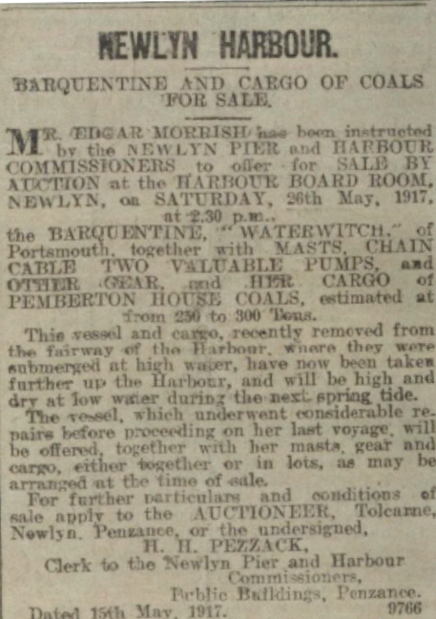
As the war was ending though, there was a severe shortage of shipping and Waterwitch‘s luck changed. Edward Stephens of Fowey bought her with her cargo. The Stephens were themselves descendants of a family well known in the fruit trade to the Azores. Thomas Stephens came & built a hut on her poop deck. He lived there & directed the discharge & sale of her cargo. He had her patched pumped & salvaged. Late one day in May 1918 she floated again. By 03.00 o clock in the morning, the day after next, she had been towed to Par Harbour & gone into Ben Tregaskes dry dock. The veteran was to be rebuilt by the Cornishmen.
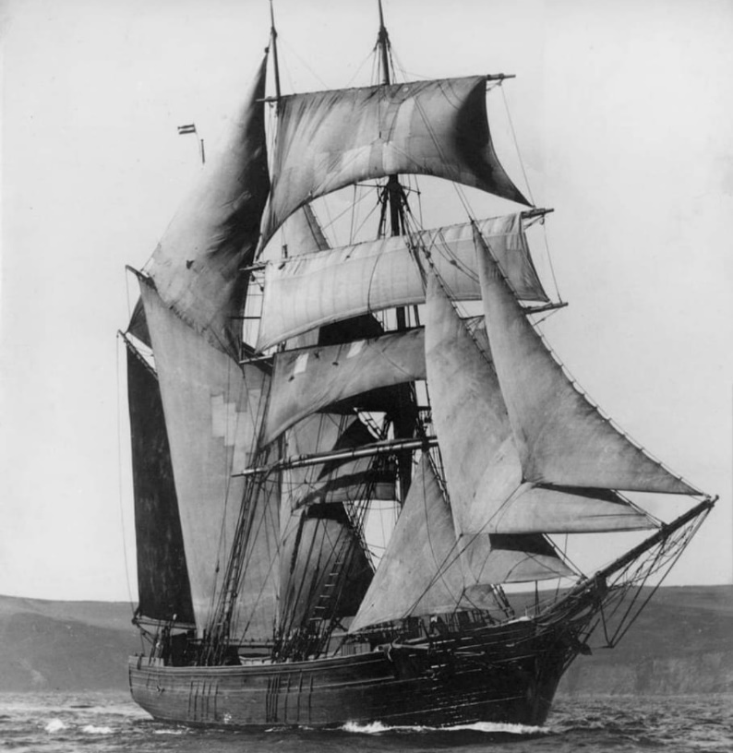
They did “a proper job”! Supervised by Captain Deacon.All above deck was renewed including her bowsprit & jiboom, except the fore & main lower masts & no Royals were fitted. Below, a foot was cut from her draft & substantial repairs made to her vital timbers, hog, keel, keelson & frames.
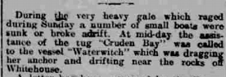

Then Captain C H Deacon took her, once more, to sea. She was never quite the ship she had been. It was considered though, that she was handier & better suited to the coastal trade.
She could still make 9.2 knots when full & bye, she retained her reputation for fast reliable passages, handled well & most importantly made a lot of money.
A typical master of the old school, Charles Deacon, born in 1862 at Beesands in Devon was an “unqualified” master of “Waterwitch“.He was a non-smoker & teetotal, universally acknowledged as one of the finest seamen & a hard driver. Two of his commands were sunk by enemy action, both during the First World War, the “Ocean Swell” and the “Bessie Stephens“. He was given command of “Waterwitch“, replacement for the “Ocean Swell” & stayed with her for 17 years. In latter days he was described as bronzed and gypsy like in appearance, including gold earrings. His dress invariably included a fur cap and 19th century style seaman’s leather thigh boots. Always a driver of ships, a favourite technique in light air and calms was to stand at the break of the quarter deck lighting matches to check for wind direction. After working on a farm, at 18 he went to sea in a Brixham schooner. He found he said, life at sea was easier than farming. Proud of being a Devon man, he soon took to sailing in Cornish vessels. He joined the Stephens fleet of Fowey & at the age of 32 was put in charge of a schooner. He was to remain in commands with the same owners for 42 years.
During his time with Stephens no ship he commanded was lost by accident.
After the war, the prosperous trades gradually declined. Keeping “Waterwitch” trading became slowly more difficult. Ridged economy kept her going well beyond most of her rivals.
Gradually as cargo became more difficult to obtain, foreign vessels could trade on England and British could not trade in most of Europe, she was neglected and suffered accordingly.
She still looked handsome, even when lying in Falmouth in the 1920’s near the restored “Cutty Sark“.
In 1927 off Rock Ferry Waterwitch was run down by the steamer Canadian Highlander.
Her bowsprit was once again bodily wrenched out. 1930 saw her in Par Docks for extensive repairs. Her hull was still sound, but it was necessary to fit a new keelson. In 1932 she was still making good passages, Plymouth to Goole in 48 hours, Fowey to Antwerp with china clay, in 32 hours, dock to dock. She continued to have narrow escapes as well, almost blowing ashore with Flambourgh Head under her lee in 1930, developing a near fatal leak soon after, & losing a topsail yard off Land’s End in yet another gale. Freight was getting harder to come by & rates were low.
As other sailing ships, great & small disappeared; “Waterwitch” sailed on into a unique place in British history. After the loss of the Garthpool in 1929, her final great distinction was to be the last British square rigged merchant sailing vessel to operate out of a home port. She became famous.
More than the last great steel deep sea traders, “Waterwitch” fittingly represented the last of the old style of ships, her size, build, rig and mode of operation truly represented the once numerous & now ghostly fleets of old. As she became unique, so she attracted the attentions of journalists, artists and adventurous young men. Often holders of a master certificate in steam, anxious to add a square sail ticket to their record served her. She took to sea many experienced mariners for seagoing training for Trinity House. They wished to qualify for Pilot & needed time in square sail for a full ticket.
In 1935, Captain B.R. Carrivick replaced Captain Deacon who retired & sadly died soon after. Carrivick sailed her well making many quick runs, Falmouth to Runcorn (on the R. Dee) in 7 days, Holyhead to Falmouth in 3 days.
The end of the “red duster” under engineless square sail finally came when in the spring of 1936. Edward Stephens, last of the British ship owners & operators, died. “Waterwitch” discharged a cargo of china clay at Weston Point & lay there through April. When new orders arrived it was appropriately to load coal at Runcorn on the Dee, she went to sea on the 5th of May bound with her final British cargo for Falmouth which she made, reliable to the end, on the 10th of May. She sailed again on the 16th of May 1936 for Par. Arriving the next day she had quietly completed the last voyage ever made with cargo by an engineless British square rigger.
She joined the “Jane Banks” (ex Frau Minna Peterson) which had also made an historic last voyage, thought barely survived it. Jane banks was the last British square rigger to trade abroad. Together they lay at first in Par harbour, latter on the beach outside, for 3 years.
They became a forlorn sight as their yards went askew, weather bleached them & seagulls whitened them. The ships attracted many potential buyers. There was talk of them becoming training ships.
Ben Tregaskis wanted to see her preserved for viewing, so the next generation “could see what they were like“. Eventually in 1939 both were sold to an Estonian partnership for approximately £1,100. Waterwitch was sold to Estonia a year after Jane Banks having also been repaired by Ben Tregaskes of Par to Board of Trade standard.
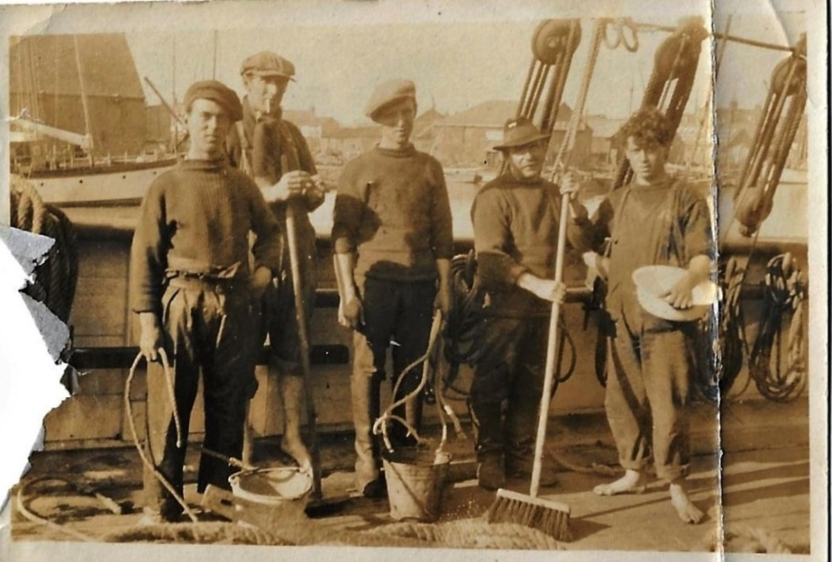
Lydon Sydney Allen’s photo
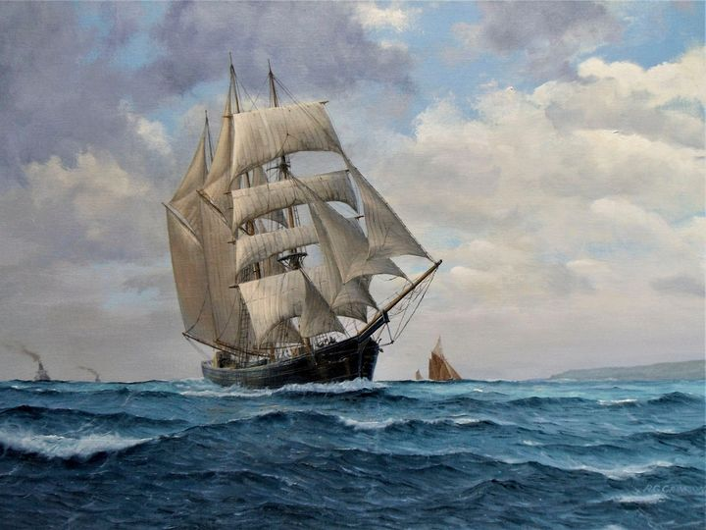
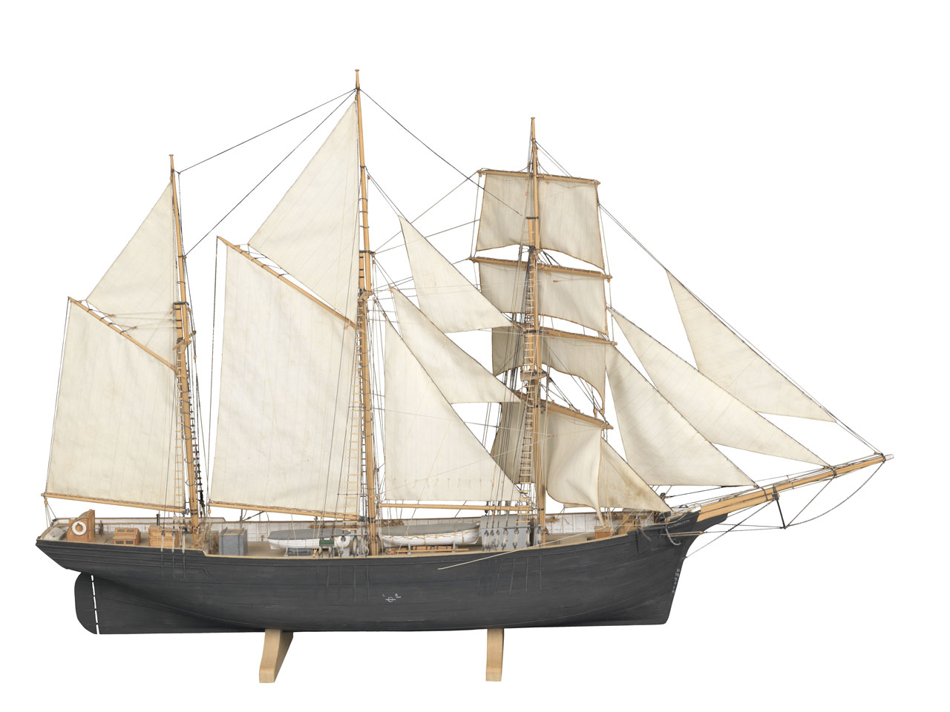
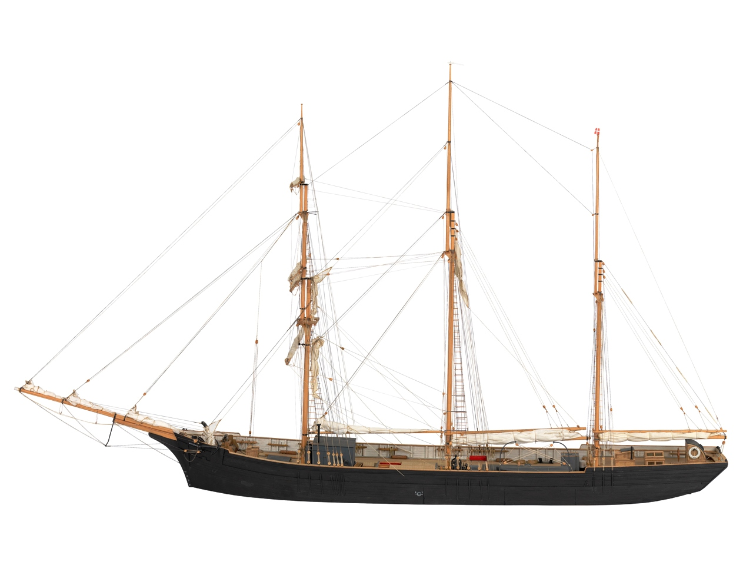
Scale: 1:48. A waterline exhibition model of the barquentine ‘Waterwitch’ (1871). The
She was refitted for the last time at Ben Tregaske’s yard then, some say she loaded china clay at Par for the Baltic. It was also reported in the Cornish Guardian and Western Morning News she left Par in ballast, towed clear by 2 motor boats and directed by Fred Dunn, pilot.
This time on the 3rd of May, under a new flag, she did finally attract a small crowd mostly of people related to the Stephens and her former captains, to see her off. Fred Dunn left her under all fore & aft canvas at 7.20 p.m., heading west towards Charlestown, As Fred Dunn left her, “Waterwitch” was looking for a slant of breeze to clear her for the English Channel and the North Sea. She reached her new home & port of register, Jagarhu on the island of Saaremaa off the coast of Estonia in 30 or 40 days. She then entered the timber trade & garnered her owners at least £400 a year.
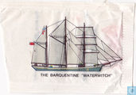
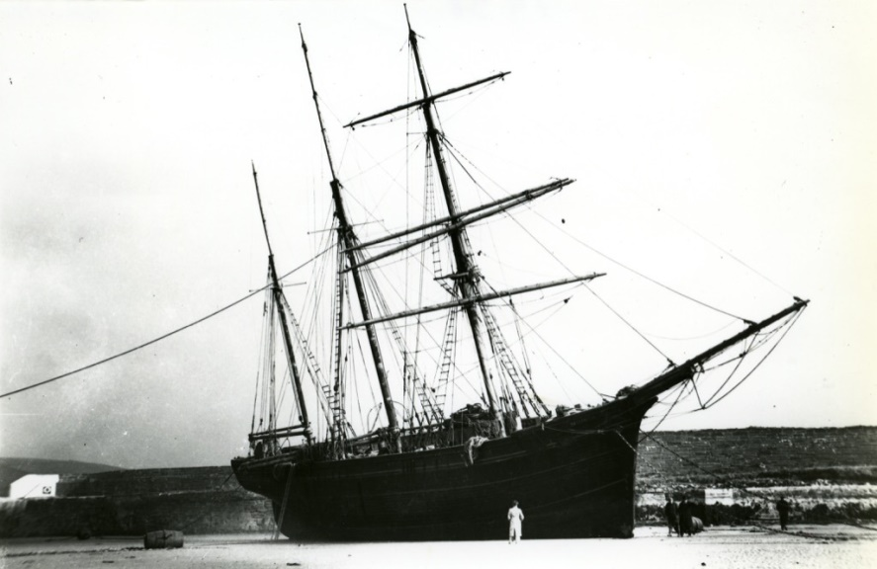
Laid up in Par Harbour
At the beginning of WW2 she was at Assene, Denmark. She sailed for her home but with the Baltic republics falling to occupation of the USSR, she was lost to British observers excepting one last report from a seaman who had known her well. He said he had seen the ship in a Baltic harbour, in her 73rd year, alas very dilapidated & the old ship was never heard of again.
The last English square rigger, an instrument which had served this country well, had left the narrow seas.
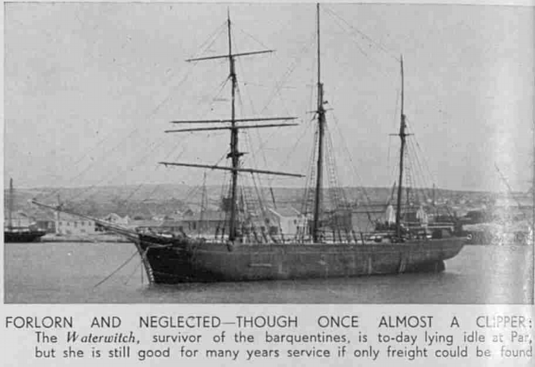

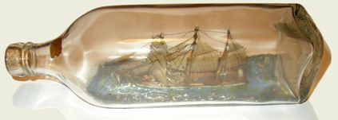
Waterwitch in a bottle, a model that is, reproduced with the kind permission of Mr S. Bailey of Poole, Dorset.
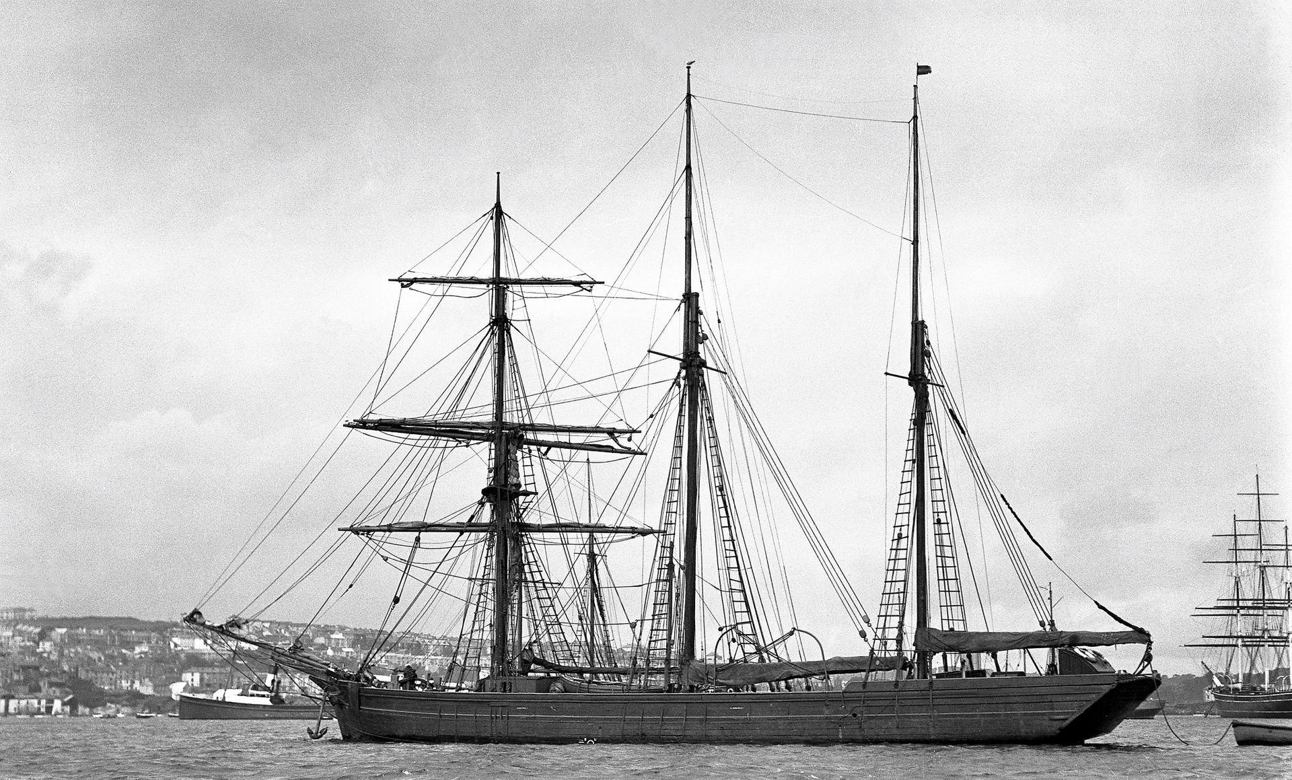
In Falmouth
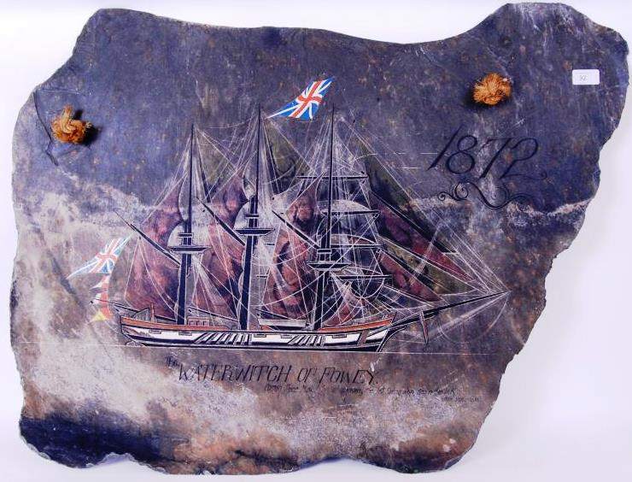

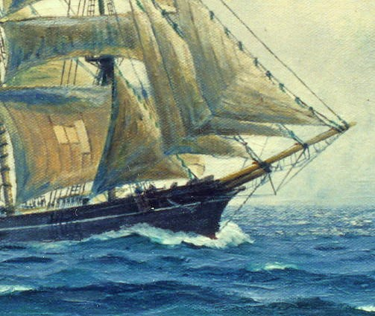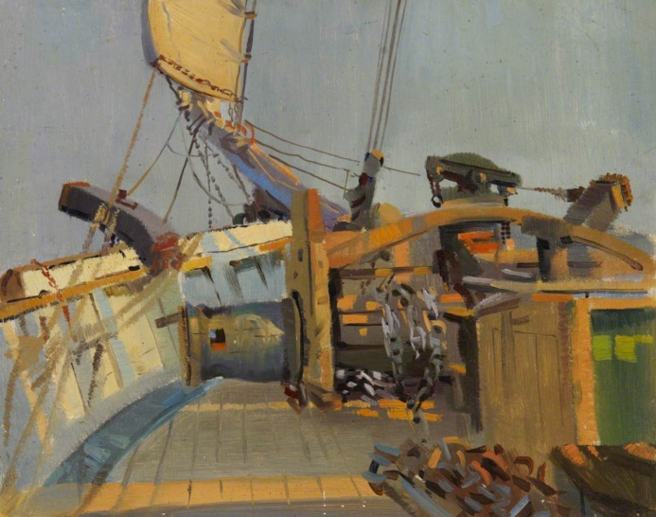

Ship: Waterwitch; Official Number: 62194.

Thomas Mutton; rank/rating, master; age, 59; place of birth, Fowey; previous ship, same.
Archibald McKechie; rank/rating, mate; age, 30; place of birth, Glasgow; previous ship, same.
John Rosaden; rank/rating, able seaman; age, 25; place of birth, Ronneby Sweden; previous ship, Marita.
C Hall; rank/rating, able seaman; age, 26; place of birth, Modbury; previous ship, Hematope.
A Taylor; rank/rating, able seaman; age, 41; place of birth, Poole; previous ship, Northerton.
T Mitchell; rank/rating, steward and cook; age, 32; place of birth, Grenada; previous ship, Bellvelle.
Henry Pearce; rank/rating, able seaman; age, 50; place of birth, St Ives; previous ship, Torfrida.
W Sharp; rank/rating, cook; age, 16; place of birth, London; previous ship, Pearl.
G Cousins; rank/rating, mate; age, 54; place of birth, Lincolnshire; previous ship, Emma and [?].
Kristo Ohin; rank/rating, able seaman; age, 27; place of birth, Rison; previous ship, Faithley.
Ligundo Anderson; rank/rating, able seaman; age, 21; place of birth, Fridrukstel; previous ship, Faithley.
Ernest J Barry; rank/rating, cook and seaman; age, 32; place of birth, Par; previous ship, Abega.
Franky McPhetridge; rank/rating, able seaman; age, 32; place of birth, Glasgow; previous ship, Maneton.
Michael Godfrey; rank/rating, able seaman; age, 28; place of birth, Bootle; previous ship, Julia.
James Jorgenson; rank/rating, able seaman; age, 49; place of birth, Rison Norway; previous ship, Edwin.
Denis Miller; rank/rating, able seaman; age, 45; place of birth, Kingstown; previous ship, Adelaide.
Charles Gudmunssen; rank/rating, mate; age, 47; place of birth, Norway; previous ship, SS Allermash.
John Tierney; rank/rating, able seaman; age, 53; place of birth, Waterford; previous ship, Polly and Emily.
Richard Webb; rank/rating, able seaman; age, 37; place of birth, Bude; previous ship, Rothersand.
Date: 1915

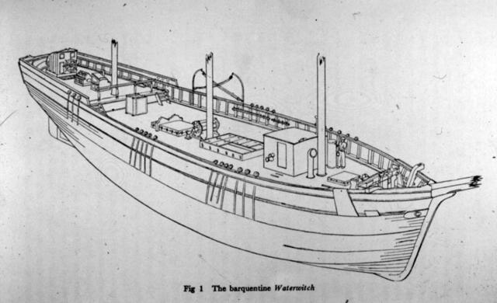
http://www.poolehistory.org.uk/node/327512

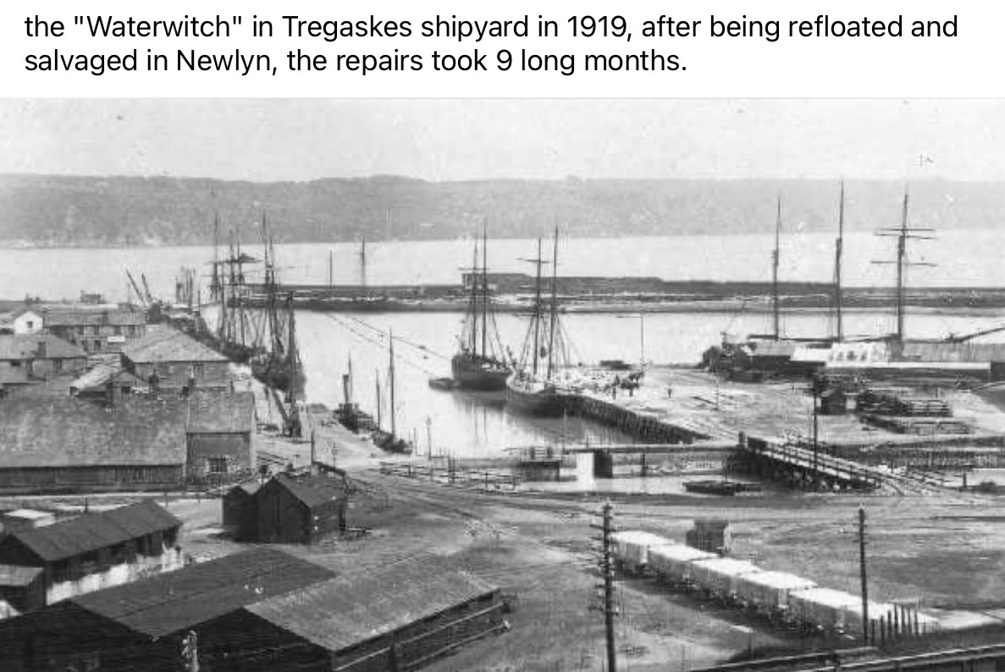

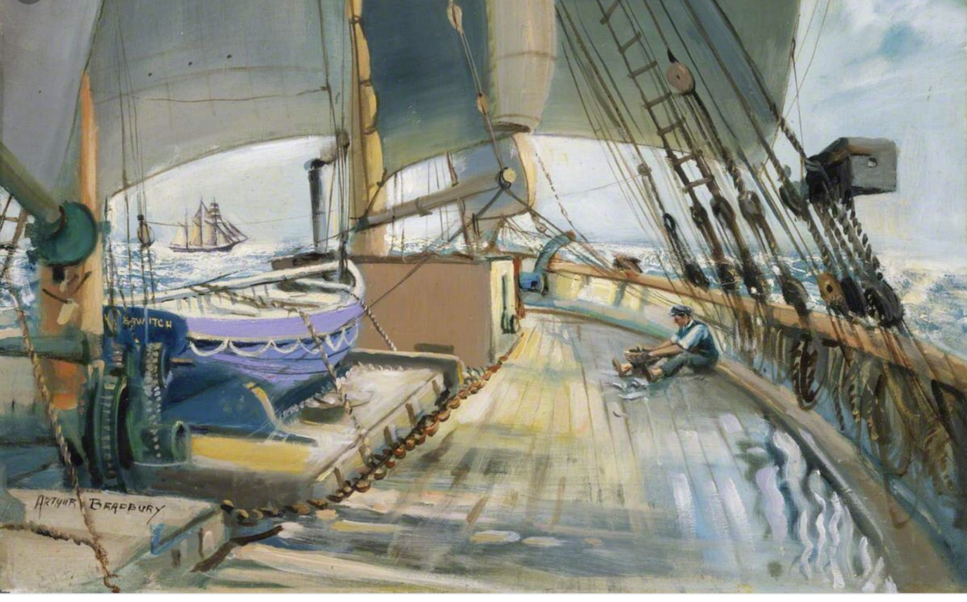

An Article written by Arthur Bradbury a crew man on the Waterwitch in Ships and Ship Models Magazine May 1932

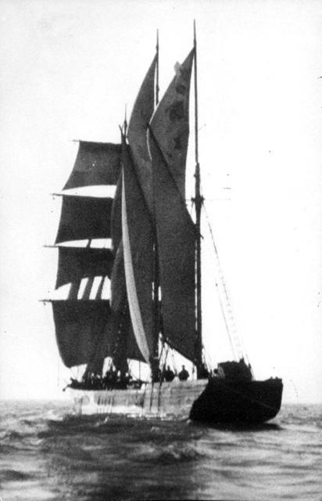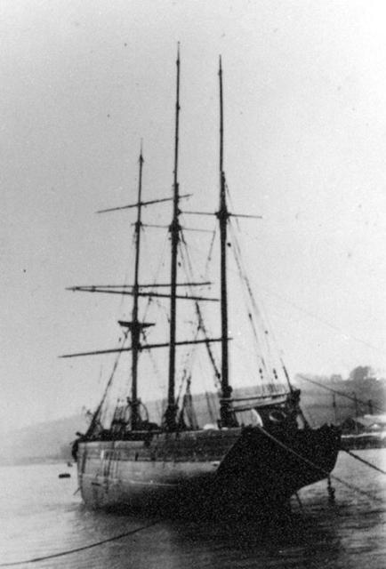

In Par. http://www.poolehistory.org.uk/

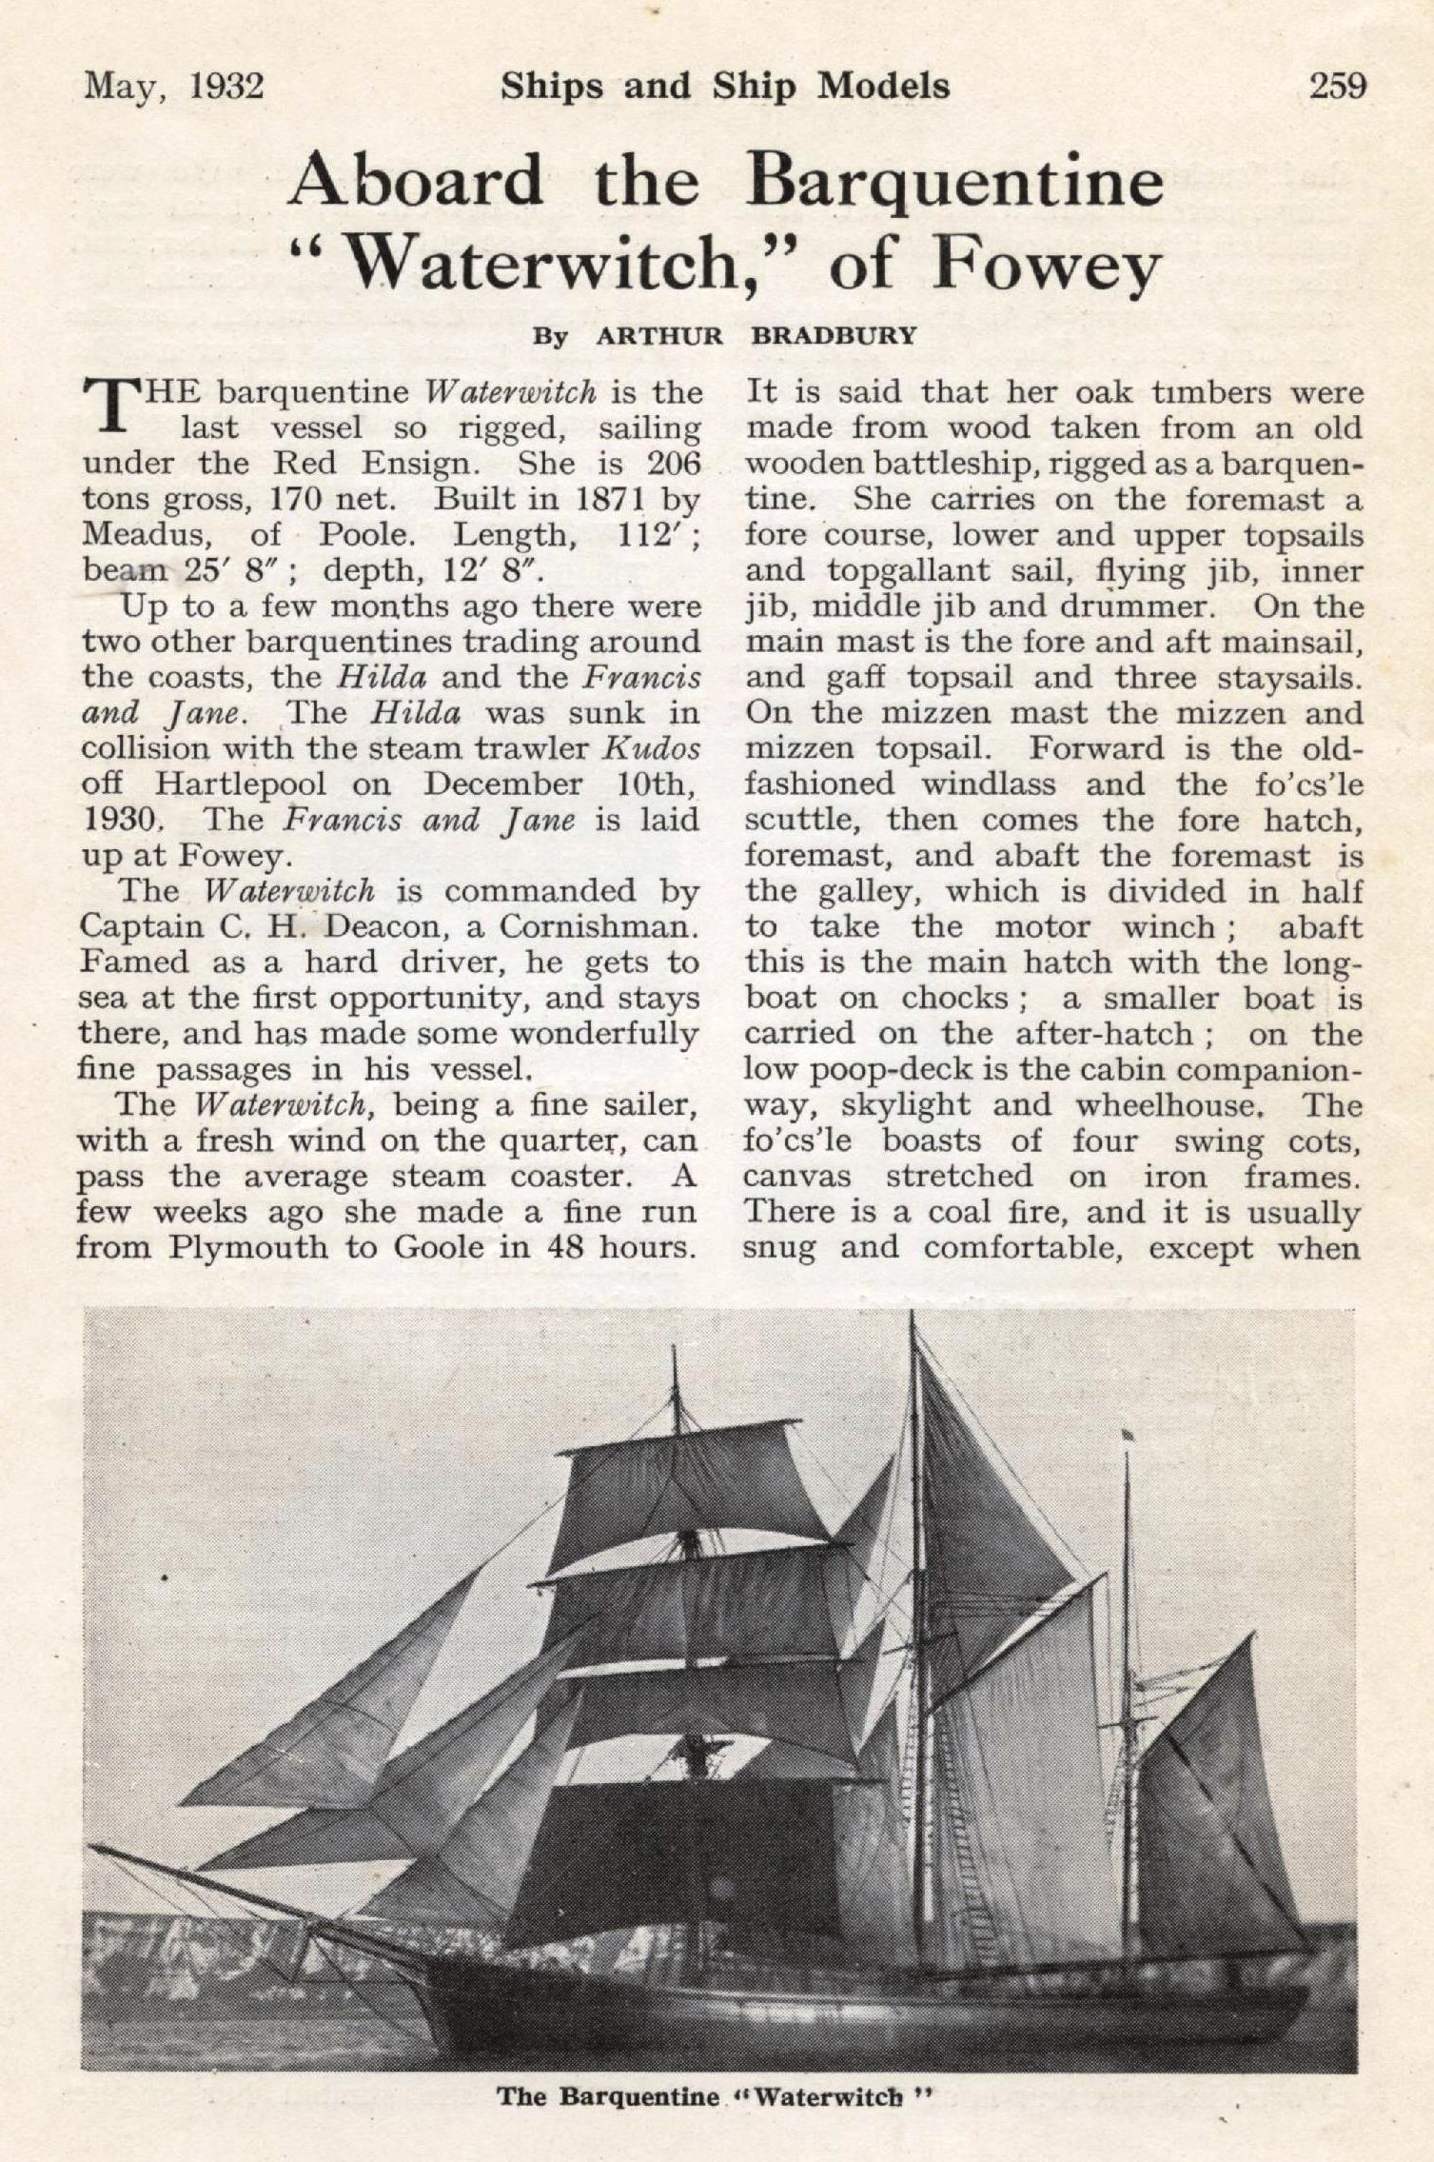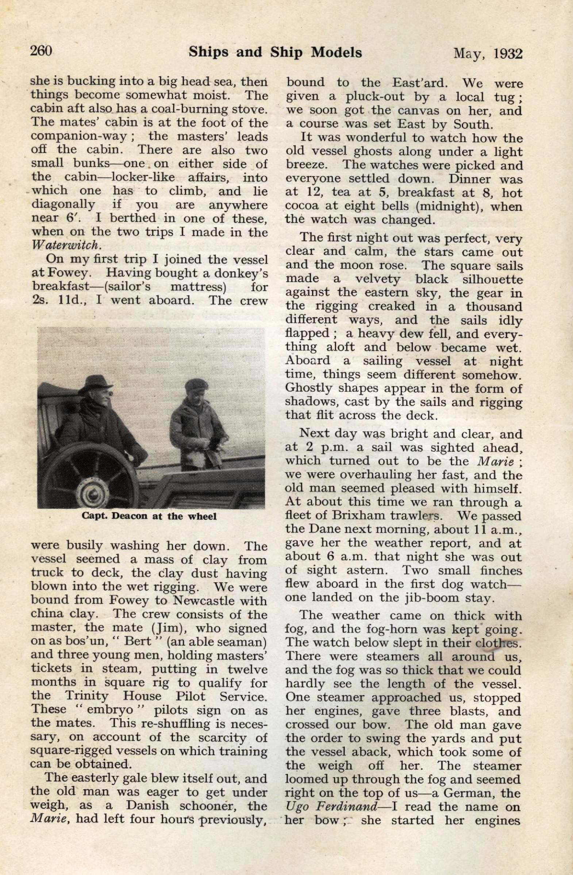

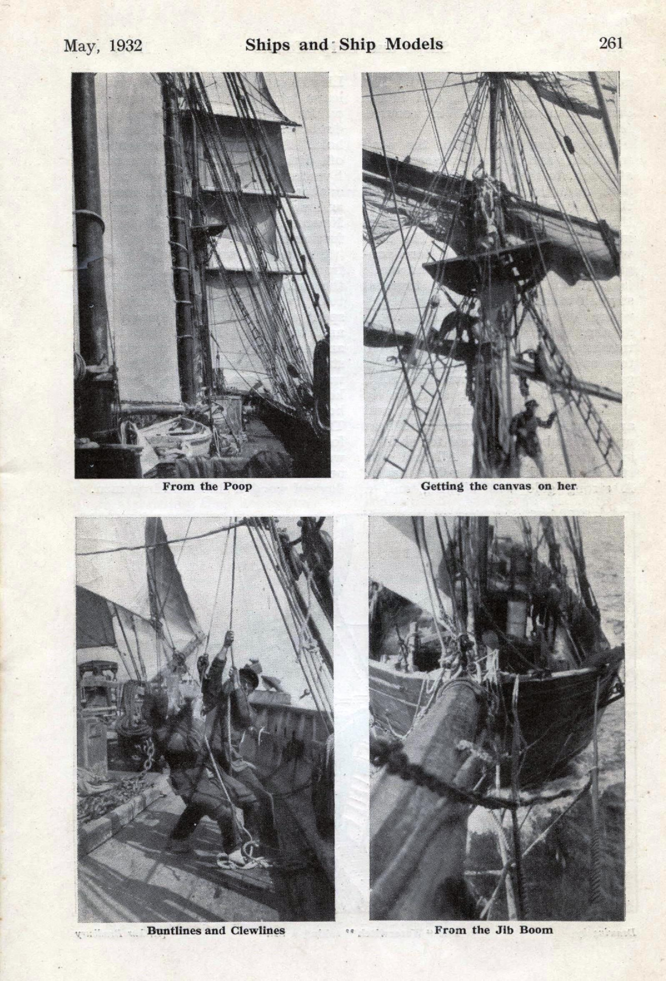

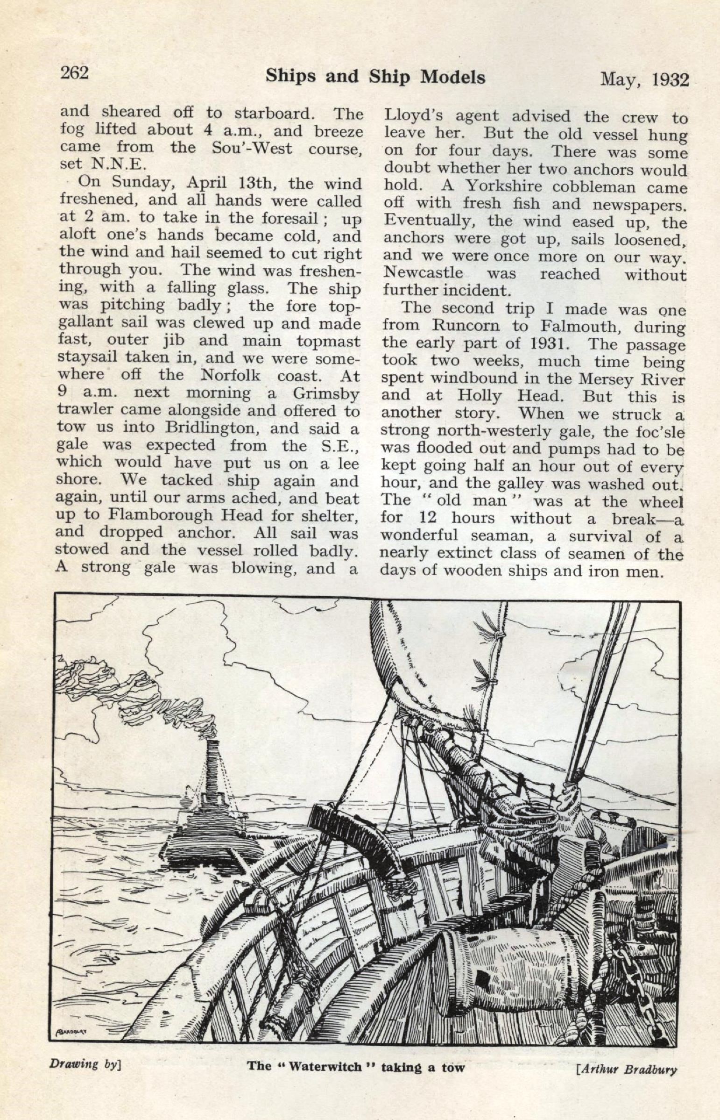
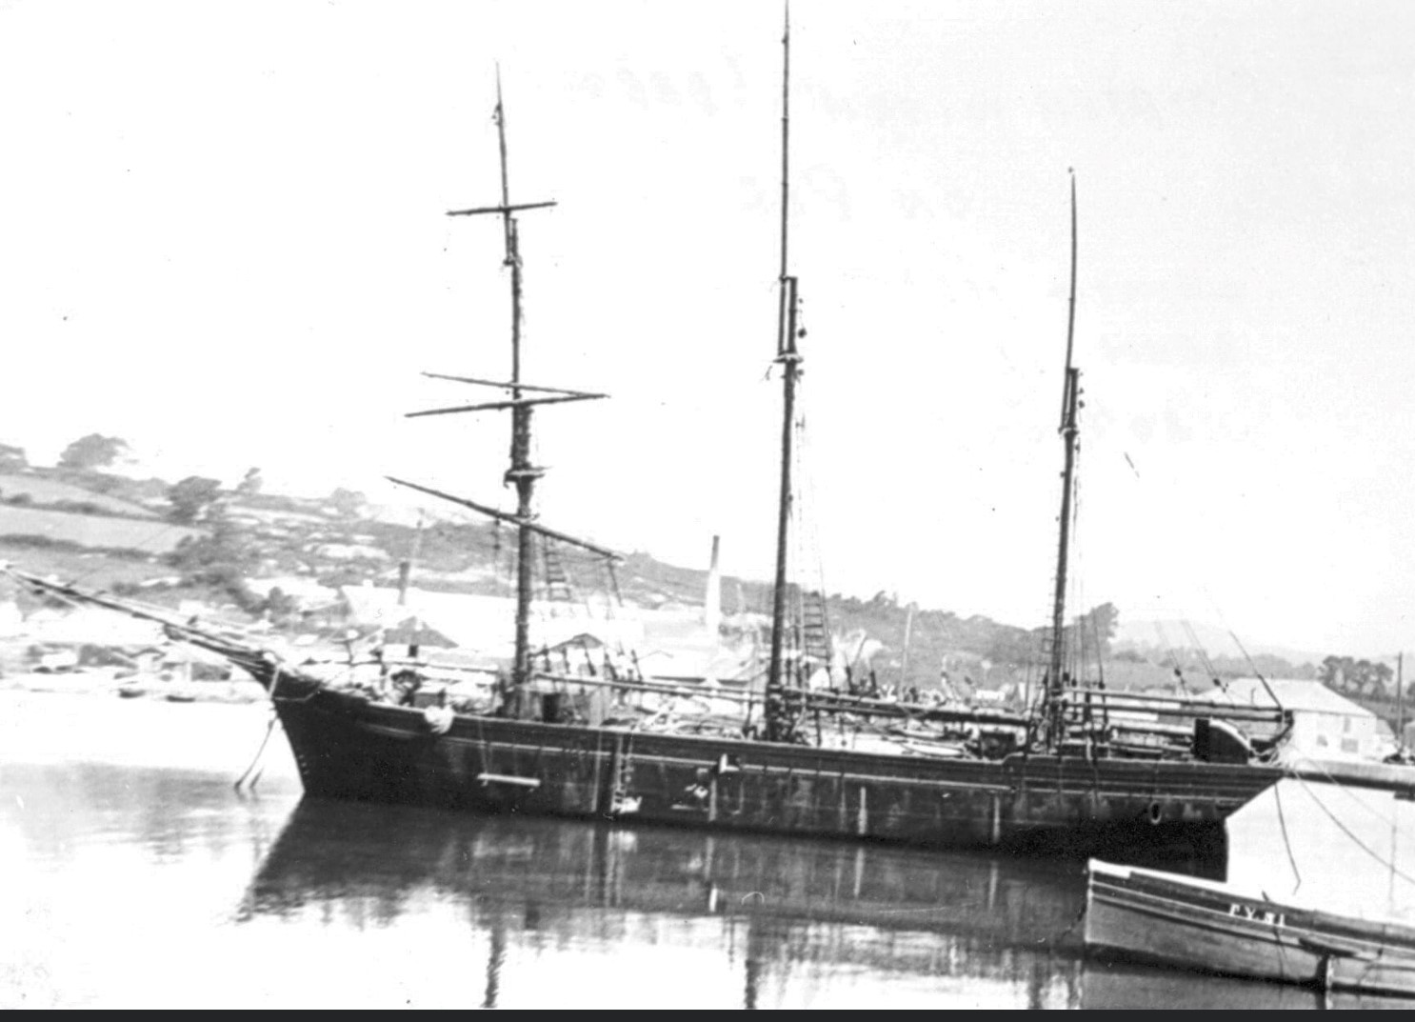

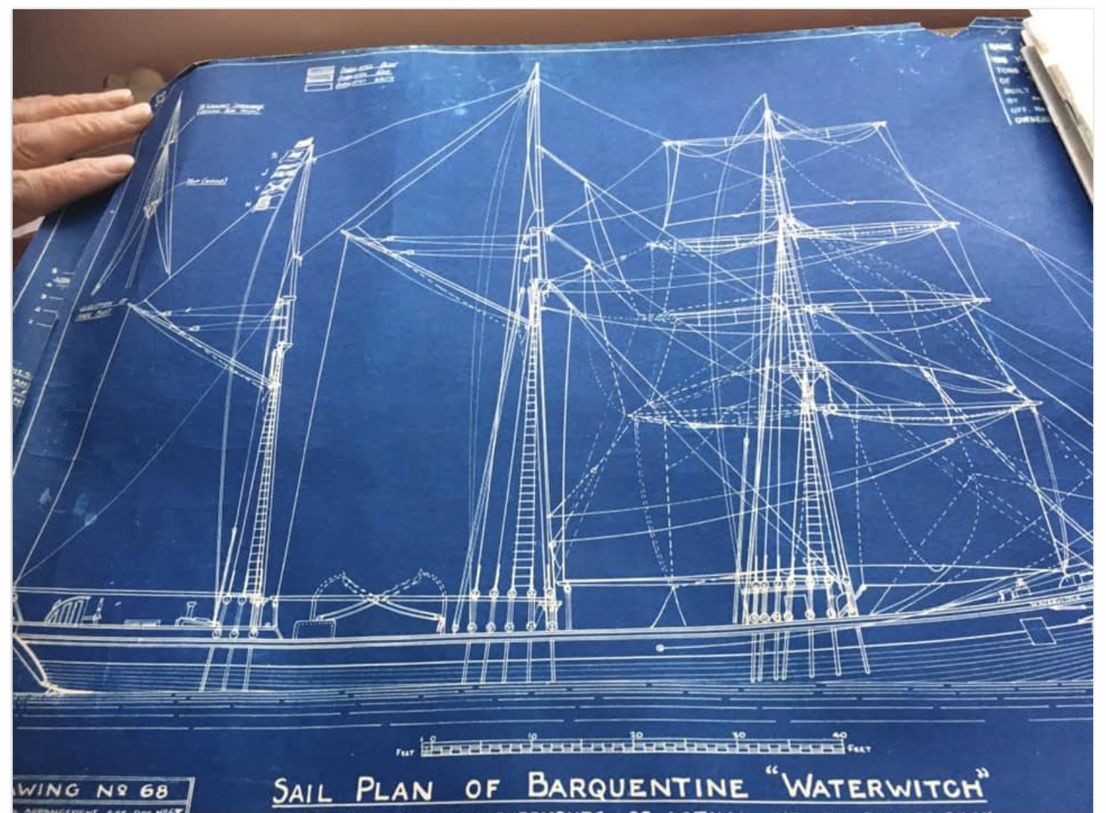

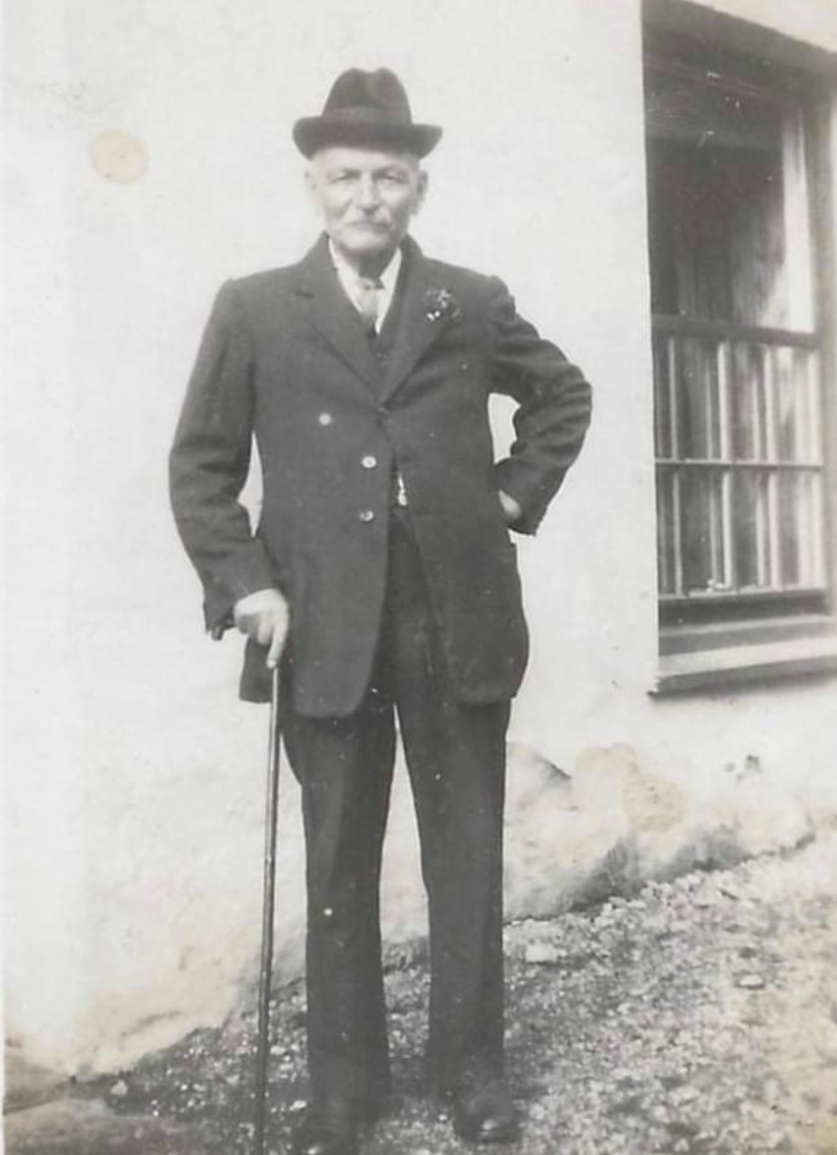

Captain Charlie Deacon

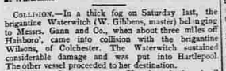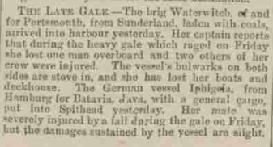

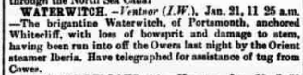

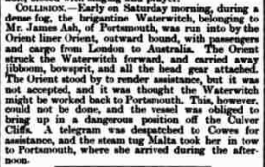
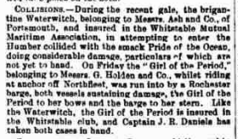

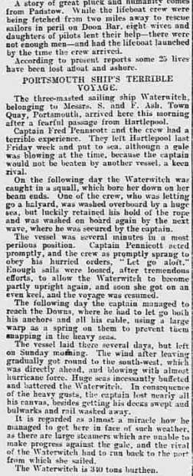

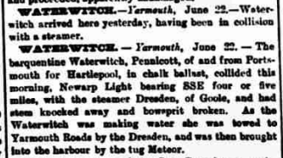

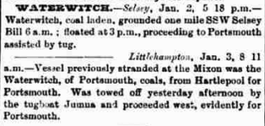

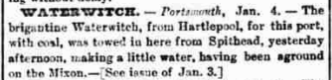

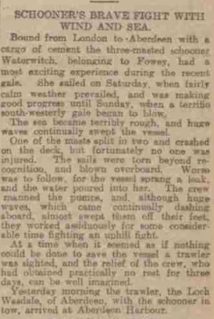

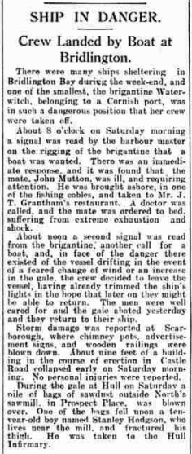

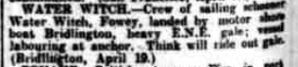
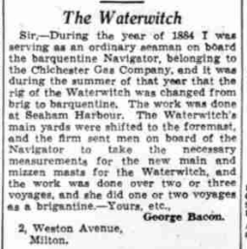
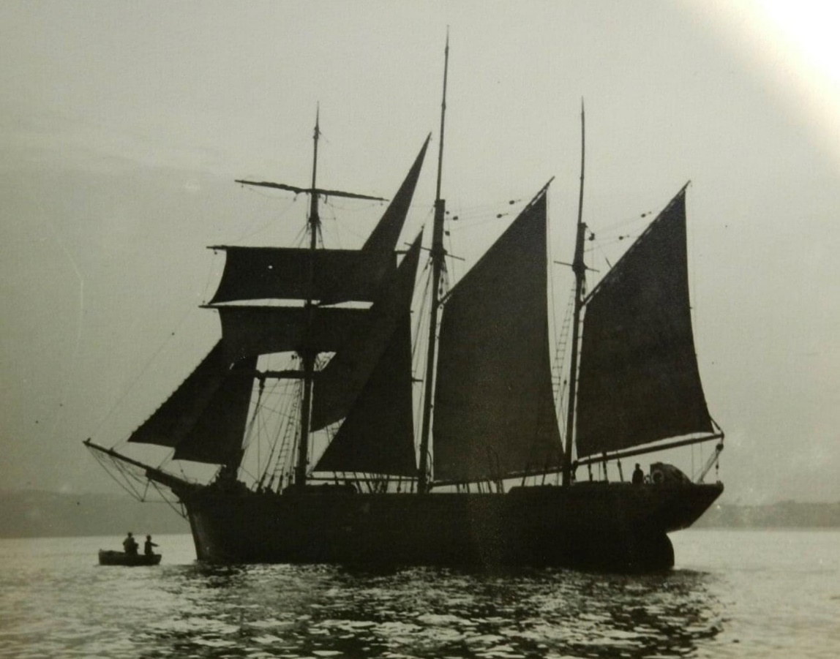
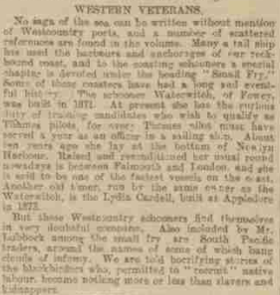

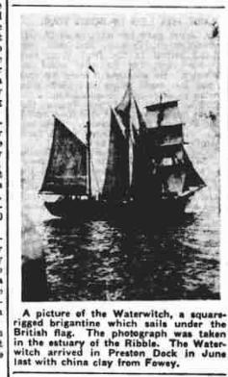

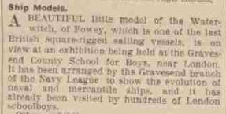

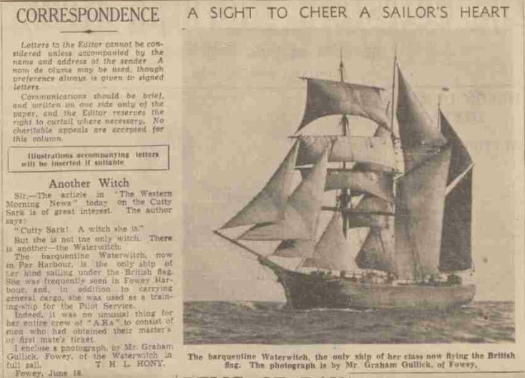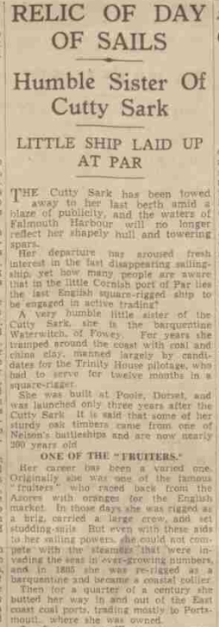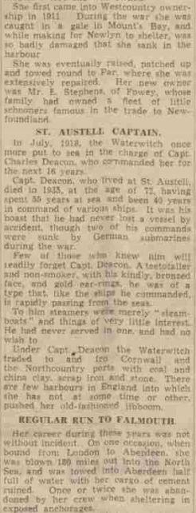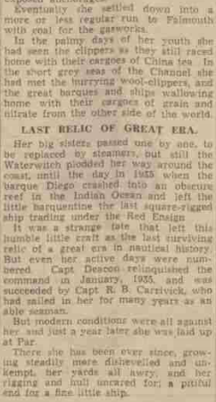

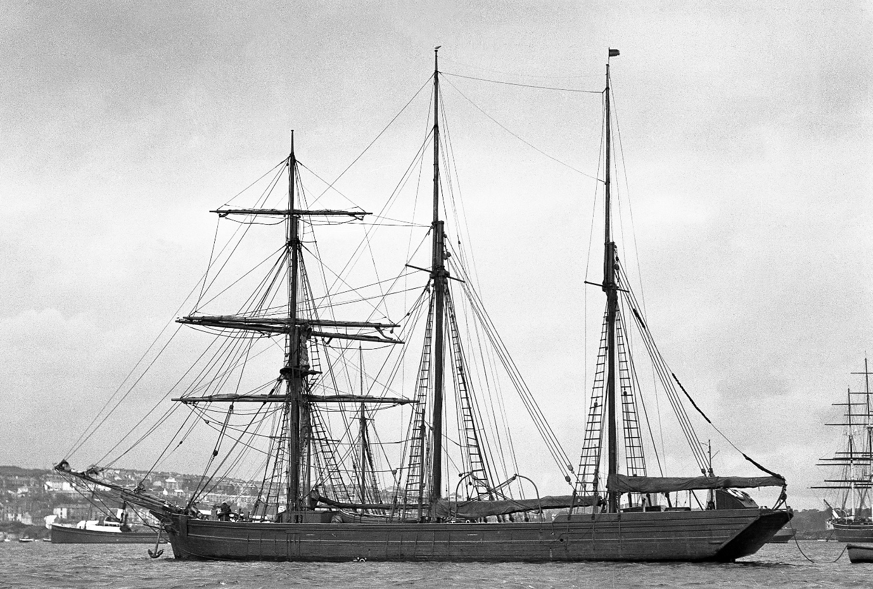

In Falmouth 1934. Cutty Sark in the background
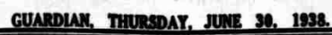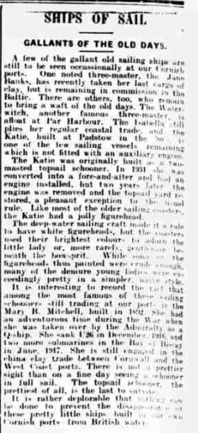

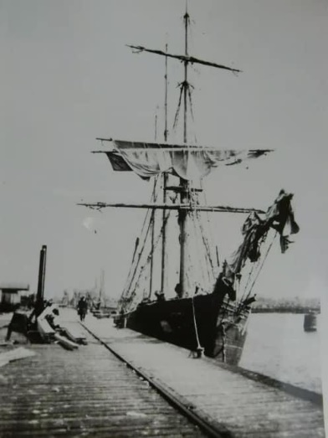
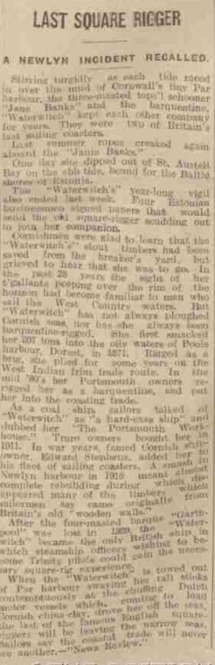

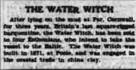

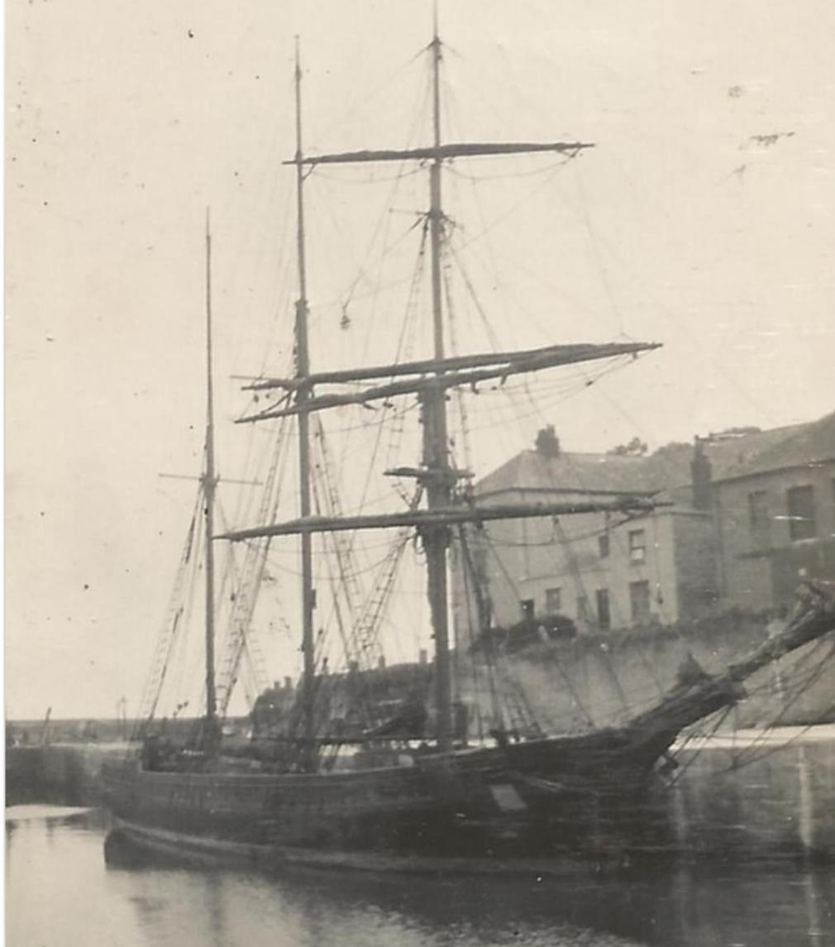

1932 in Charlestown

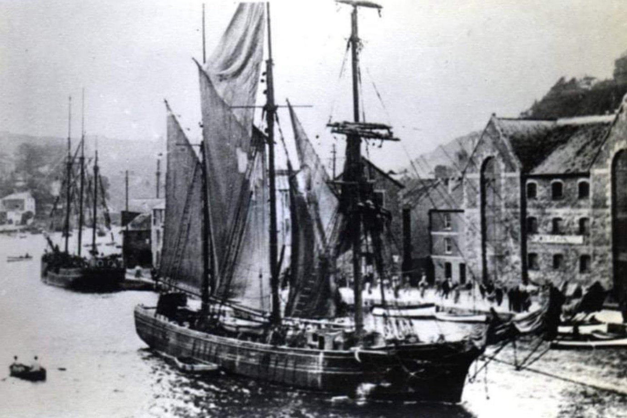

Being towed out of Looe.

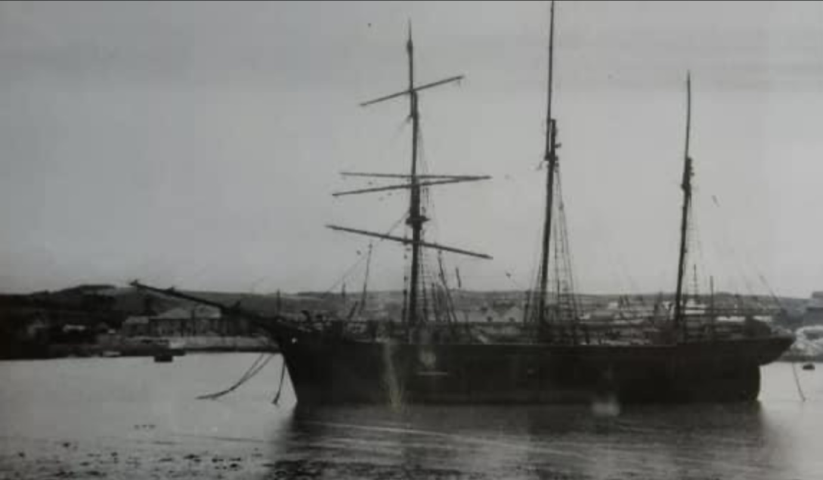
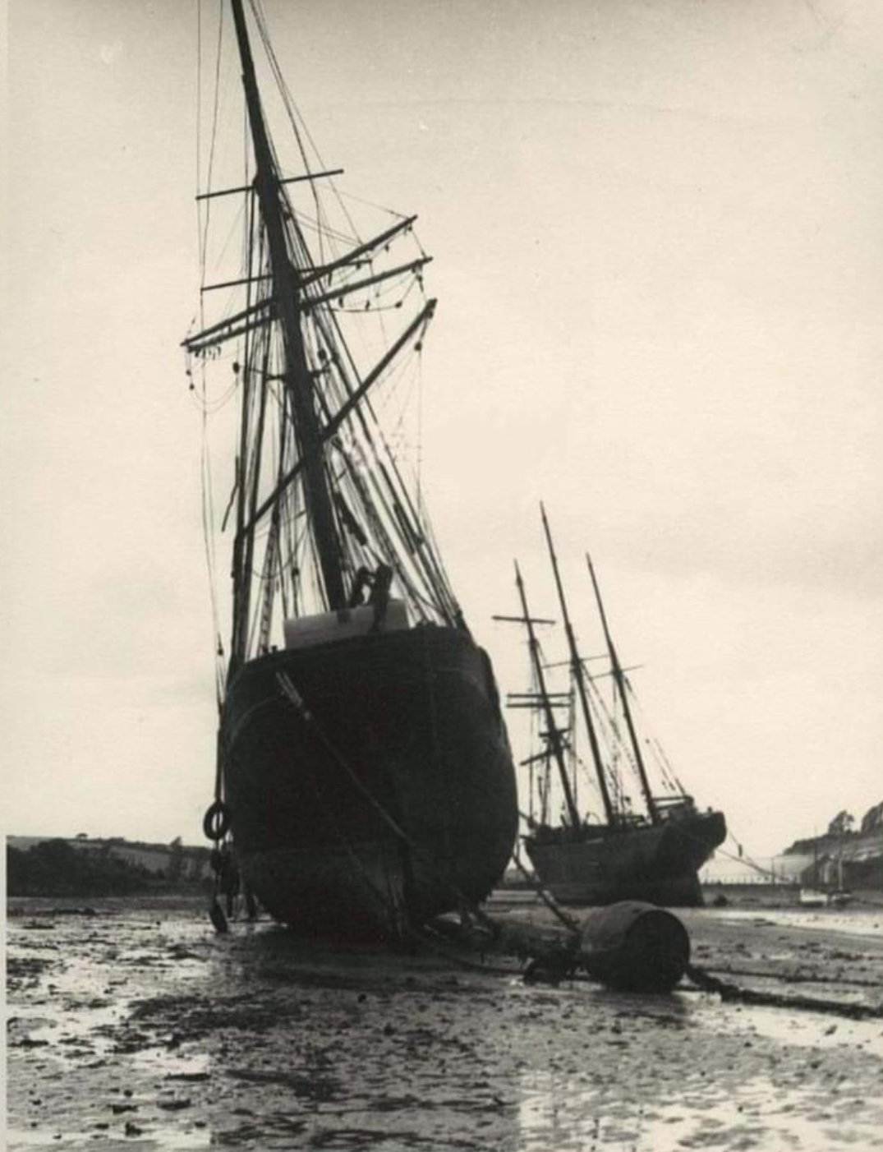

Laid up in Par with the Jane Banks

An Article from National Maritime Museum by Lindsey Skinner – in Bartlett Blog ,news 21st June 2021
https://nmmc.co.uk/2021/06/waterwitch-the-last-of-the-line/

Waterwitch – The Last of The Line

Built in 1871 by the Poole shipwright Thomas Meadus, Waterwitch had spent most of her working life trading in north European waters mainly around the British Isles and France carrying coal cargoes. In 1934 Waterwitch was a well-known sight in Falmouth discharging coal at the gasworks, now a harbourside car park but that life was drawing towards its close. By the end of the decade Waterwitch ceased to be the last British square rigged sailing ship to carry cargo around the coast.

The Cornish Connection

Waterwitch was first registered in 1872 in Portsmouth and owned by Henry and James Ash, coal and potato merchants. She was retained by the Ash family until 1905 when she was purchased by Lieutenant Colonel Flowers, also of Portsmouth. Apart from a transatlantic voyage carrying wheat from Montreal to Galway, she mainly carried coal from Seaham in North East England to Portsmouth and the South Coast. In 1910 Waterwitch came into Cornish hands when she was bought by Mr Mutton of Fowey, refitted at Truro and based in Falmouth. After being purchased in 1918 by the Fowey shipowner Edward Stephens she remained in Cornwall, carrying coal and china clay, until 1939 when she was sold to Estonian owners.

A Career Full of Incident

Initially Waterwitch was built as a brig, a vessel with two square rigged masts but by 1884 the ship had been reconfigured as a barquentine, a vessel with a square rigged foremast and the remaining masts rigged fore and aft. This alteration was to improve the sailing qualities and during a long career in the coastal trade the vessel gained a reputation for reliability, speed and power. However it was also a career which was almost legendary in being full of incident. In 1877 Waterwitch was badly damaged by foul weather in the Solent requiring extensive repairs and later was involved in a collision with a steamer, also in the Solent, which caused damage to the bow and bowspit. In 1884 under the command of Captain Madgewick the alterations were made to convert the vessel to a barquentine but unfortunately on New Year’s Day 1885 the Captain fell overboard and was drowned. In the ensuing years as a hard working vessel mainly carrying cargoes of coal and china clay around the British coast there were various other incidents which required frequent repairs and replacements.
During World War I Waterwitch had two brushes with enemy submarines the second of which was a torpedo attack which fortunately failed. Fully laden with coal sailing from Runcorn for Falmouth the Waterwitch tried to enter Newlyn harbour in 1916 during a strong south easterly and struck the bottom. Badly damaged along her keel and with the rudder torn off the vessel was barely afloat when finally lifted. Fire had also damaged the stern above the waterline and she was a forlorn sight. However, she was purchased by the Fowey shipowner Edward Stephens and eventually towed to Par in May 1918 and rebuilt by there by Tregaskes.
Edward Stephens transferred the ship to the Fowey register under the command of Captain Charles Deacon of Charlestown a well-known and characterful seaman who was captain for the next 17 years. Waterwitch also remained a successful and prosperous coastal trader although she continued to have narrow escapes and incidents such as in 1927 when she was run down off Rock Ferry by the Canadian steamer Highlander. In 1935 Captain Deacon retired and in the spring of 1936, Edward Stephens had died bringing his business of sailing ships to an end. On 5th May 1936 Waterwitch loaded a final cargo of coal at Runcorn which arrived five days later in Falmouth. On 16th May the ship sailed empty from Falmouth for the last time for Par where she remained for the next three years, first in the harbour and then beached, until sold to Estonian owners in 1939. Loaded with a cargo of china clay she sailed for the Baltic and finally sank there off the north coast of Estonia in autumn 1944.

A Happy Ship

Despite a long history of incidents Waterwitch was regarded as a happy ship and there was no problem in recruiting crews. There were up to ten in a crew including the master, the mate and a cook. The crew all ate together, and the accommodation was considered to be good of its type. The ownership remained in relatively few hands over the years and captains were chosen for their sailing abilities, and their qualities in training and managing a successful crew.
Until 1937 British steamship officers wishing to train as pilots needed experience in square- rigged vessels before Trinity House would employ them. After 1929 Waterwitch was the last British vessel able to provide this and in the later ‘Cornish’ years numerous young officers obtained valuable training under Captain Deacon’s command.
The photograph taken from the exhibition is of a sailing ship which had a hard-working life full of incident and which, by the time the image was taken, was fast becoming obsolete. Nevertheless, it still had an honesty of design and an elegance of purpose which had served it well and makes for memories to be remembered.
On January 27th, 1917, the wooden brigantine WATERWITCH, on voyage from Garston to Fowey, was wrecked at the entrance of Newlyn Harbour.
Read more at wrecksite: https://wrecksite.eu/wreck.aspx?207177

